SDP 16 UML Sequence Diagram

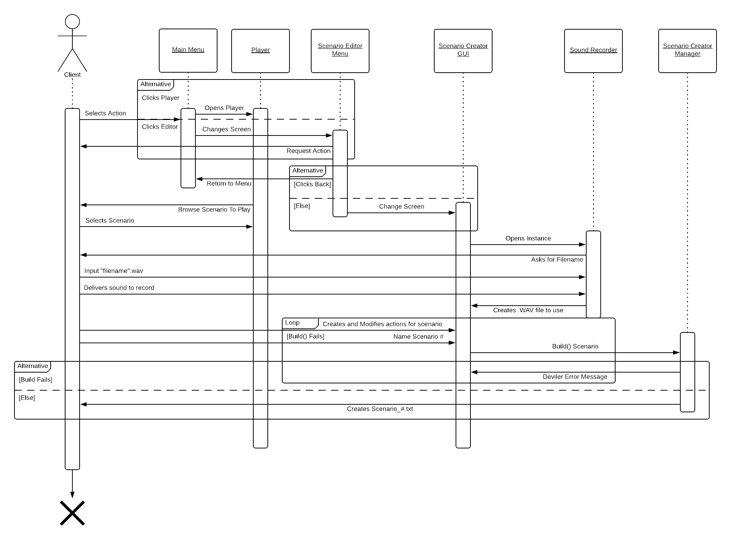The following is a sequence diagram depicting the high-level access points for the client during normal use of the SDP 16 TBB